**Tables Screenshots**

***TABLE SUPPLIER_T*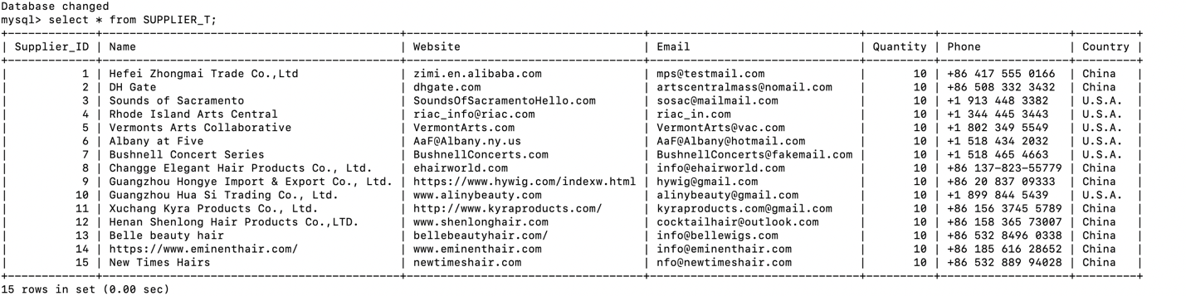**

***TABLE ORDER_DETAILS***

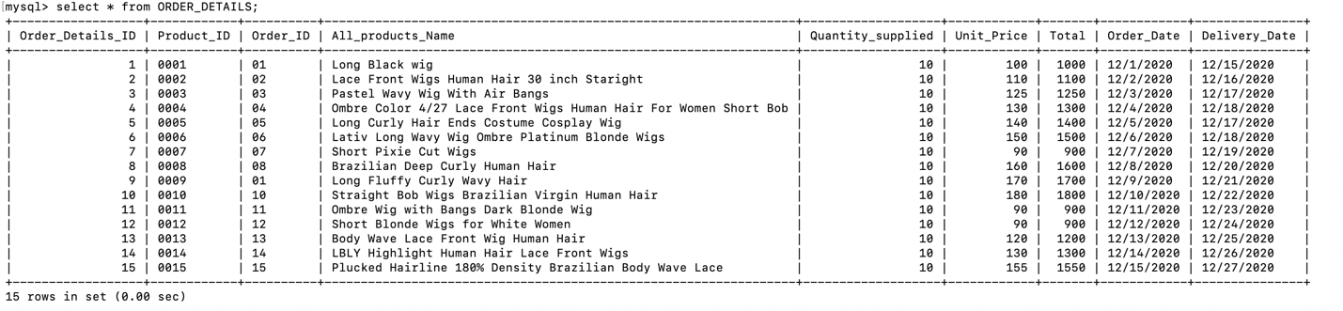

***TABLE INVENTORY_T***

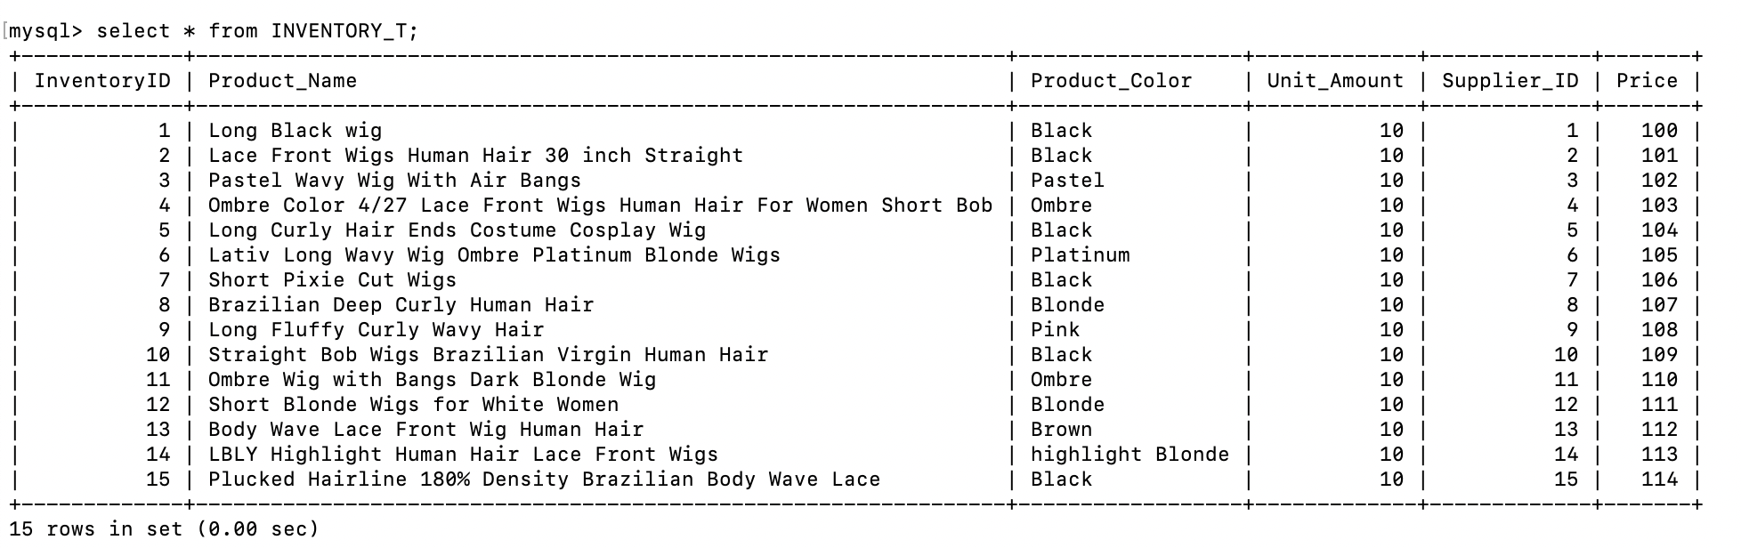

***CUSTOMERS_T***

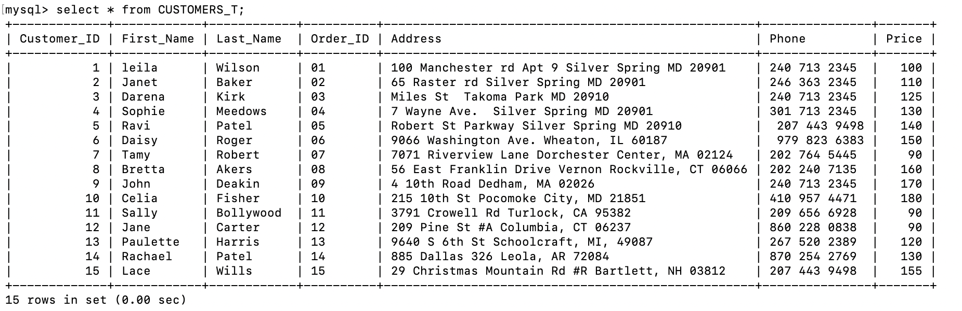

***CUSTOMER_ORDER_T***

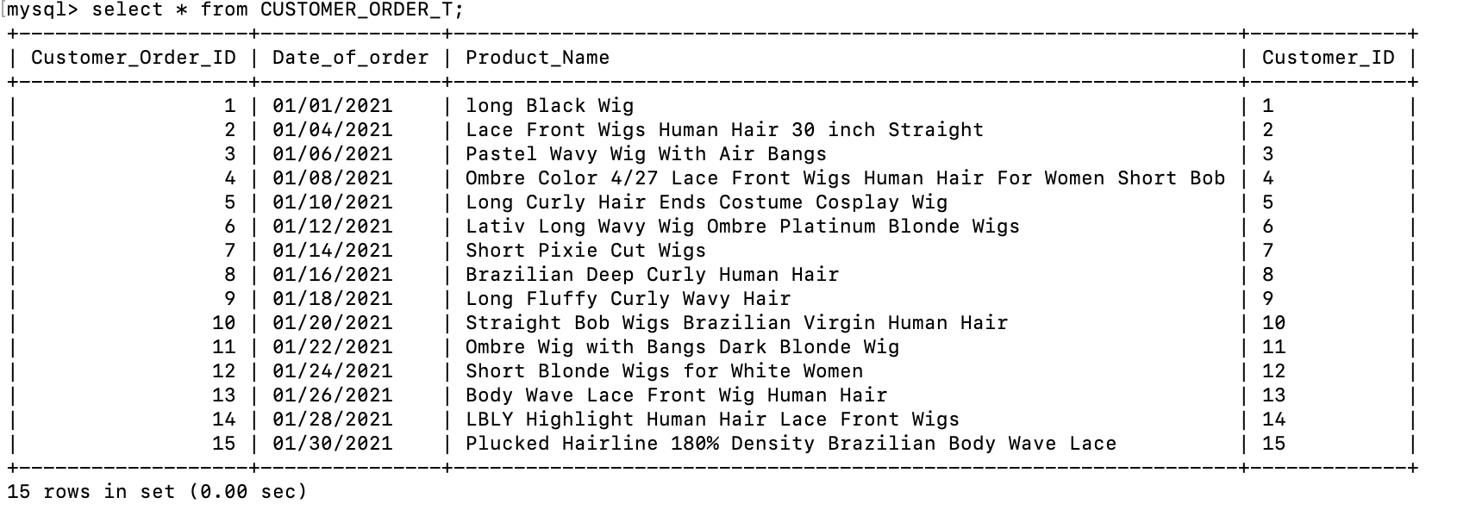

***PAYMENT_T***

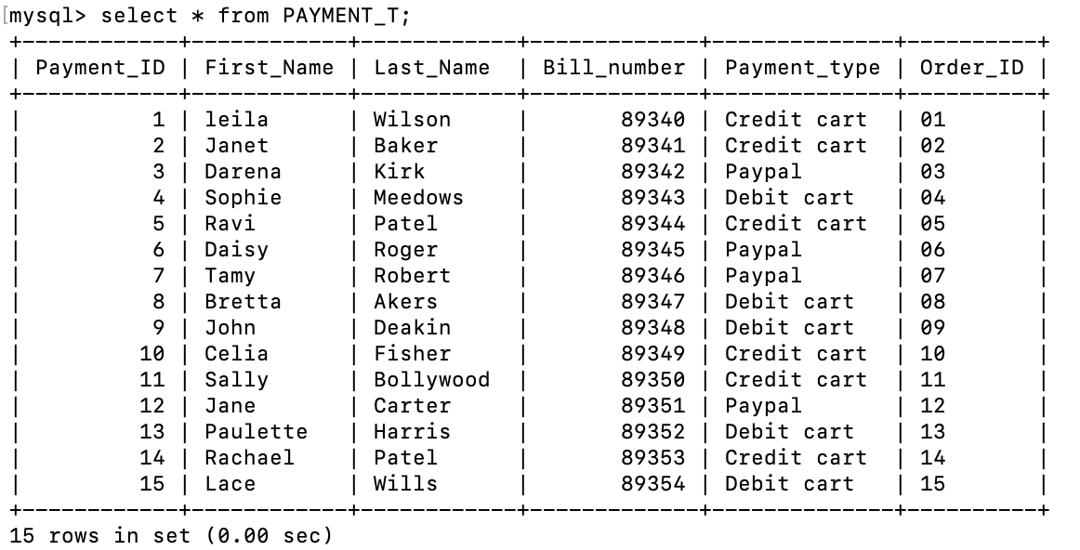

***DELIVERY_T***

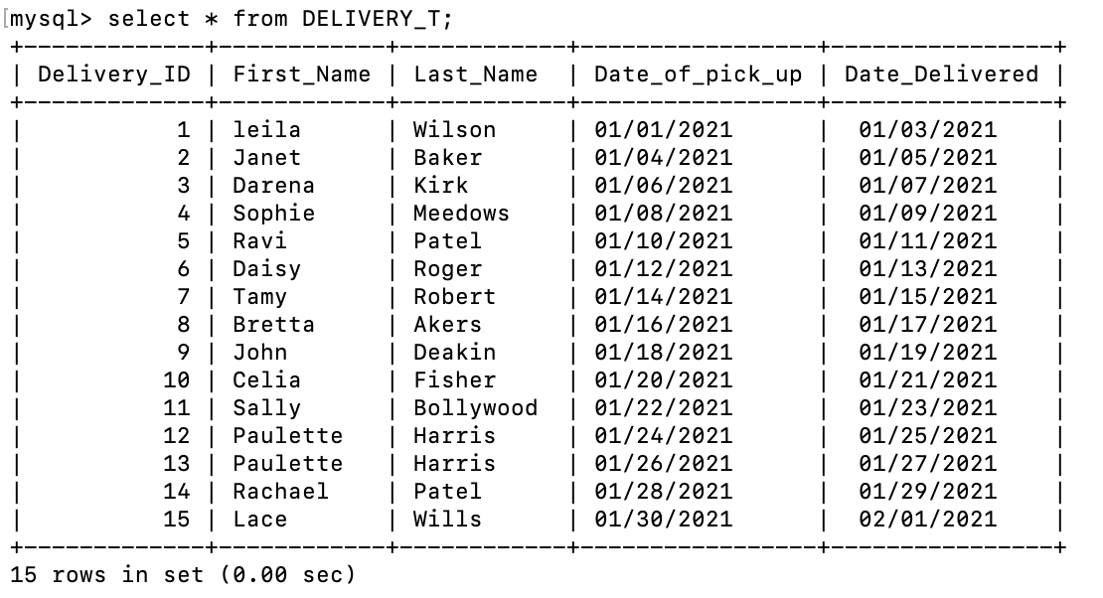

***SURVEY_T***

